EXP NO 7: CREATE A VIRTUAL MACHINE WITH 1 CPU, 2GB RAM AND 15GB STORAGE DISK USING A TYPE 2 VIRTUALIZATION SOFTWARE.

DATE: 3.11.2025
AIM:
To create a virtual machine with 1 cpu, 2gb ram and 15gb storage disk using a type
2 virtualization software.
PROCEDURE:
STEP 1:Dowload VMware workstation and installed as type 2hypervisor.
STEP2:Dowload ubuntu or tiny OS as iso image file.
STEP 3: In VMware workstation->create new VM.
STEP 4: Do the basic configuration settings.
STEP 5: Created tiny OS virtual machine.
STEP 6: Launch the VM.
IMPLEMENTATION:
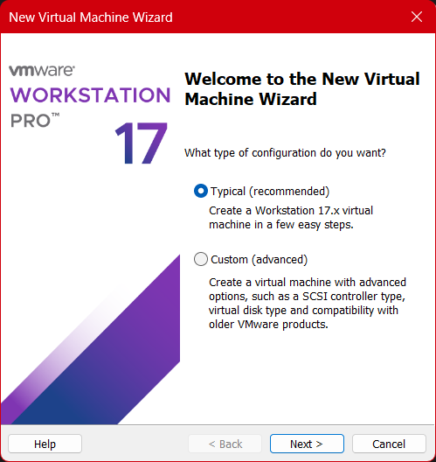

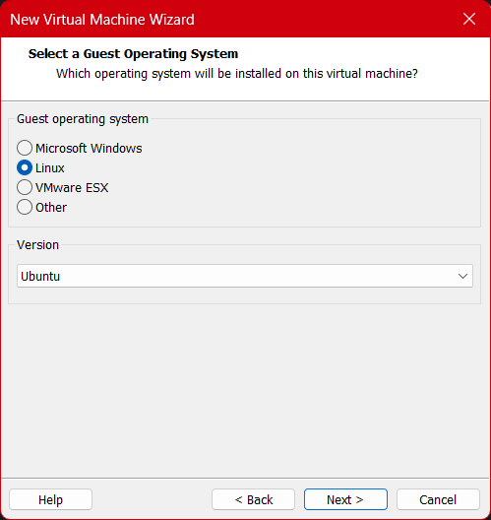
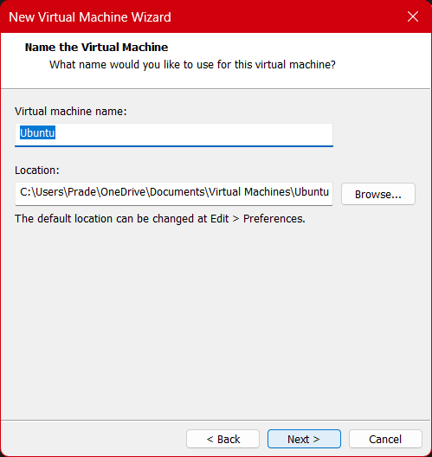

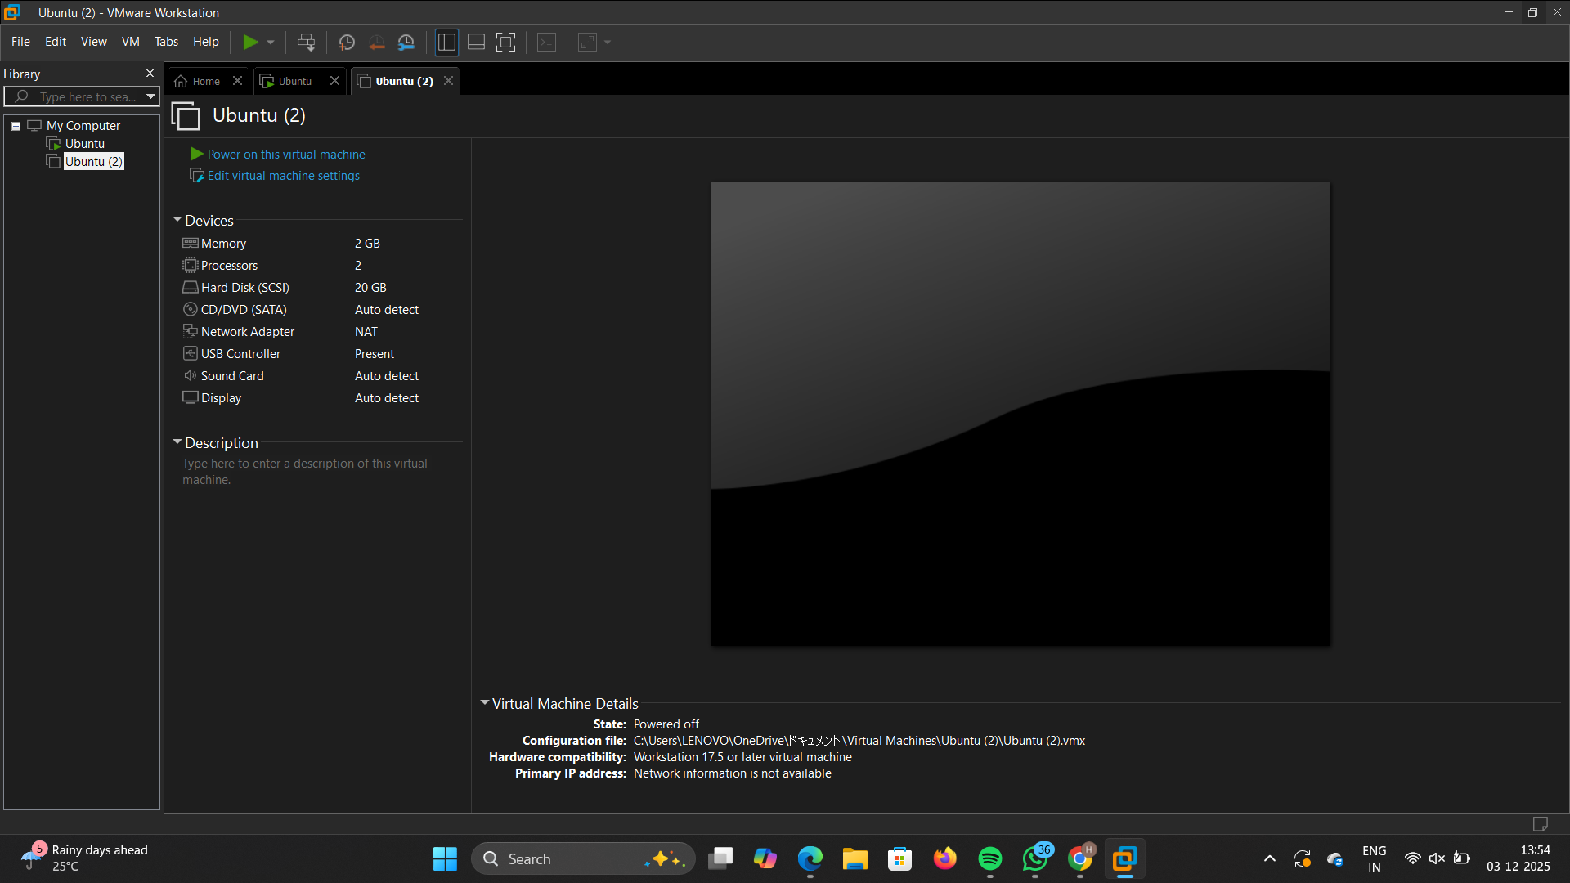

Result:
Virtual machine with 1 cpu, 2gb ram and 15gbstorage disk using a type
2 virtualization software has been created.

